|  |  |
| --- | --- |
| Name | Umar Hayyat |
| Roll No | 2019-EE-360 |

**Lab No 5**

**Loops**

**Objective:**

In this lab

* I will learnt the use of while loop.
* I will learnt about the use of do while and for loop.
* I will learnt how to find factorial of any integer.

**Task 1:**

Write a program using while loop that keeps asking the user to enter a number until -1 is entered. Then displays the number values entered, the sum of all the entered numbers and its average.

**Code:**

import java.util.Scanner;

public class Infinite {

public static void main (String []args){

int y, x=0;

int counter=0;

int sum=0;

float averg;

Scanner scan=new Scanner (System. in);

while (x>=0)

{

System.out.println ("Enter a integer: ");

y=scan.nextInt();

if(y==-1)

break;

sum=sum +y;

counter++;

x++;}

averg=sum/counter;

System.out.println ("Number entered "+counter);

System.out.println ("Sum= "+sum);

System.out.println ("Average= "+averg);

}}

**Output:**

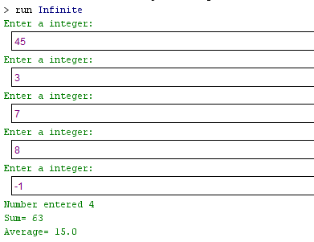

**Task 2:**

Write a program using while loop that asks a user to enter the total number of students enrolled in Computer Programming class.

Then asks the user to enter the marks obtained by each student in this class. Display the average marks obtained.

**Code:**

import java.util.Scanner;

public class Mark {

public static void main (String [] args) {

int a, b, c;

int sum=0;

Scanner mark=new Scanner (System. in);

System.out.println ("Enter the total number of students enrolled in Computer Programming class");

a=mark.nextInt ();

c=0;

while(c<a)

{

System.out.println ("Enter student marks");

b=mark.nextInt();

sum=sum+b;

c++;}

float averg=sum/a;

System.out.println ("Average marks= "+averg);

}}

**Output:**

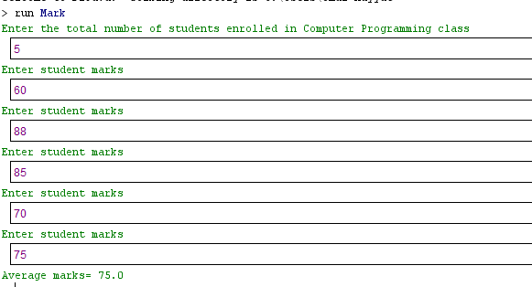

**Task 3:**

Write a program which computes the factorial of a positive integer using do-while loop.

N factorial is: n! = (n)(n- 1)(n- 2)....(3)(2)(1)

**Code:**

import java.util.Scanner;

public class Factorial {

public static void main (String [] args) {

int x, y, z;

y=1;

Scanner fact=new Scanner (System. in);

System.out.println ("Enter integer");

x=fact.nextInt();

z=1;

do

{

z=z*y;

y++;

} while(y<=x);

System.out.println("Factorial of "+x+" is "+z);

}}

**Output:**

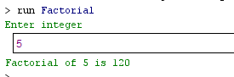

**Task 4:**

Write a program using do-while loop that prints the first 20 odd numbers which are not divisible by 3.

**Code:**

public class Odd {

public static void main (String [] args) {

int z=1;

do

{

if (z%2!=0 & z%3!=0)

System.out.println(z);

a++;

} while (z<20);

}}

**Output:**

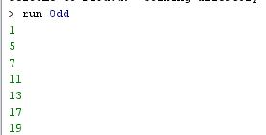

**Task 5:**

Write a program using for loop which displays the table of entered number. (1-20)

**Code:**

import java.util.Scanner;

public class Table {

public static void main (String [] args) {

int a, b, c;

Scanner scan=new Scanner(System. in);

System.out.println("Enter number");

a=scan.nextInt();

for(b=1;b<=20;b++)

{

c=b*a;

System.out.println(a+" * "+b+" = "+ c);

}

}}

**Output:**

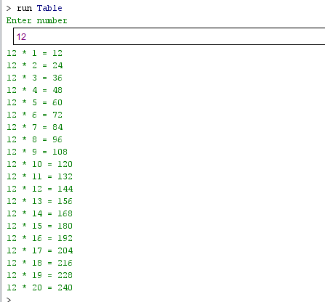

**Conclusion:** In this lab, I learnt that when we want to run the sane statements more than one time then we use loops statement i.e. while, do while and for loop. It consume very less time as compare to write those statement are repeated. As I use loops to find factorial, to print table of any integer etc.